### **Dockers**

### 

### **Model, Application, and Containers**

When we discussed the *production environment*, it was composed of two primary programs, the **model** and the **application**, that *communicate* with each other through the **endpoint** (***interface***).

* The **model** is simply the *Python model* that's created, trained, and evaluated in the ***Modeling*** component of the *machine learning workflow*.
* The **application** is simply a *web* or *software application* that *enables* the application users to use the *model* to retrieve *predictions*.

Both the **model** and the **application** require a *computing environment* so that they can be run and available for use. One way to *create* and *maintain* these *computing environments* is through the use of ***containers***.

* Specifically, the **model** and the **application** can each be run in a ***container*** *computing environment*. The ***containers*** are created using a ***script*** that contains instructions on which software packages, libraries, and other computing attributes are needed in order to run a *software application*, in our case either the **model** or the **application**.

#### **Containers Defined**

* A ***container*** can be thought of as a *standardized collection/bundle of software* that is to be *used* for the specific purpose of *running an application*.

As stated **above** ***container*** *technology* is *used to create* the **model** and **application** *computational environments* associated with ***deployment*** in machine learning. A common **container** software is *Docker*. Due to its popularity sometimes *Docker* is used synonymously with **containers**.

#### **Containers Explained**

Often to first explain the concept of ***containers***, people tend to use the analogy of how Docker *containers* are similar to shipping containers.

* Shipping containers can contain a wide variety of products, from food to computers to cars.
* The structure of a shipping container provides the ability for it to hold *different types* of products while making it *easy* to track, load, unload, and transport products worldwide within a shipping container.

Similarly *Docker* **containers**:

* Can *contain* ***all*** types of *different* software.
* The structure of a *Docker* **container** enables the **container** to be *created*, *saved*, *used*, and *deleted* through a set of *common tools*.
* The *common tool set* works with ***any*** **container** regardless of the software the **container** contains.

#### **Container Structure**

The image **below** shows the basic structure of a **container**, you have:

* The underlying *computational infrastructure* which can be: a cloud provider’s data center, an on-premise data center, or even someone’s local computer.
* Next, you have an *operating system* running on this computational infrastructure, this could be the operating system on your local computer.
* Next, there’s the *container engine*, this could be *Docker* software running on your local computer. The *container engine* software enables one to create, save, use, and delete containers; for our example, it could be *Docker* running on a local computer.
* The final two layers make up the composition of the *containers*.
  + The first layer of the container is the *libraries* and *binaries* required to launch, run, and maintain the *next* layer, the *application* layer.
* The image **below** shows *three* containers running *three* different applications.

This *architecture* of **containers** provides the following *advantages*:

1. Isolates the application, which *increases* security.
2. Requires *only* software needed to run the application, which uses computational resources *more efficiently* and allows for faster application deployment.
3. Makes application creation, replication, deletion, and maintenance easier and the same across all applications that are deployed using containers.
4. Provides a more simple and secure way to replicate, save, and share containers.

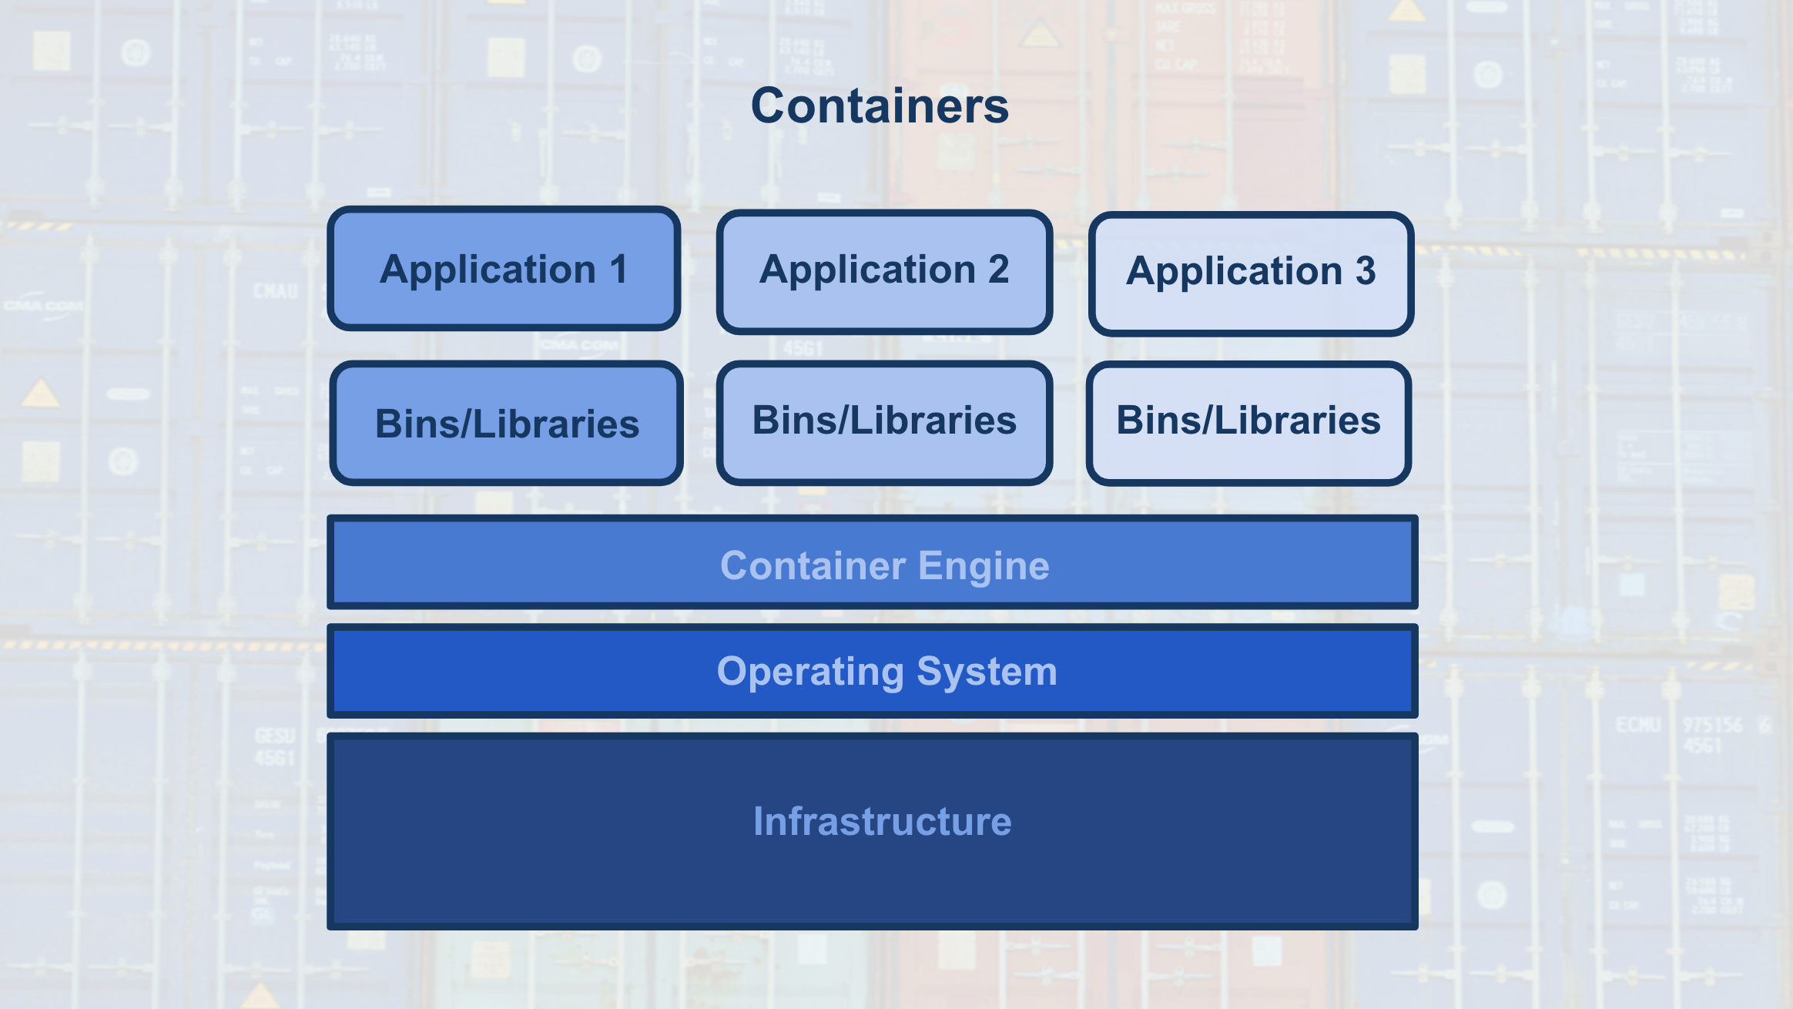

As indicated by the ***fourth*** *advantage* of using ***containers***, a ***container*** *script file* is used to create a ***container***.

* This *text* *script file* can easily be shared with others and provides a simple method to *replicate* a particular ***container***.
* This ***container*** *script* is simply the *instructions (algorithm)* that is used to create a ***container***; for *Docker* these ***container*** *scripts* are referred to as *dockerfiles*.

This is shown with the image **below**, where the *container engine* uses a ***container*** *script* to create a ***container*** for an application to run within. These ***container*** *script files* can be stored in repositories, which provide a simple means to share and replicate *containers*. For *Docker*, the [Docker Hub](https://hub.docker.com/explore/) is the official repository for storing and sharing *dockerfiles*. Here's an example of a [dockerfile](https://github.com/pytorch/pytorch/blob/master/docker/pytorch/Dockerfile) that creates a docker container with Python 3.6 and PyTorch installed.

